
SCHOOL OF COMPUTING AND INFORMATIC
BACHELOR OF SCIENCE IN INFORMATION TECHNOLOGY
UNITE TITLES: SCIENTIFIC COMPUTING
UNITE CODE: BIT2118
SUBMITTED BY: AYUB HUSSEIN
REG. NO: BSCCS/2024/56898
SUPERVISOR: MUGAMBI DENIS DR

Contents
How each task is presented 3
Task 2: NumPy Arrays and Numerical Computation 4
Task 3: Mathematical Functions and Vectorization 6
Task 4: Floating-Point Arithmetic and Numerical Errors 8
Task 5: Matrix Algebra and Matrix Operations 10
Task 6: Solution of Systems of Linear Equations 13
Task 7: Gaussian Elimination and LU Decomposition 15
Task 8: Iterative Methods for Linear Systems 17
Task 9: Eigenvalues and Eigenvectors 20
Task 10: Root Finding: Bisection and Fixed-Point Methods 22
Task 11: Root Finding: Newton-Raphson and Secant Methods 25
Task 12: Polynomial and Nonlinear Equation Solving 27
Task 13: Interpolation 29
Task 14: Curve Fitting and Approximation 32
Task 15: Numerical Differentiation 35
Task 16: Numerical Integration 38
Task 17: Ordinary Differential Equations – Euler Method 40
Task 18: Numerical Solution of ODEs Using SciPy 43
Task 19: Numerical Optimization 46
Task 20: Random Numbers and Monte Carlo Methods 48

Task 2: NumPy Arrays and Numerical Computation
Program file: code/Task_02_numpy_arrays.py

B. Inputs and mathematical operation
- Input: 24 hourly temperature readings in °C, stored in one NumPy array.
- Operations: mean = (sum of readings)/24, minimum, maximum, and the conversion F = 1.8C + 32 applied to every element at once (vectorized).

Output of the original program
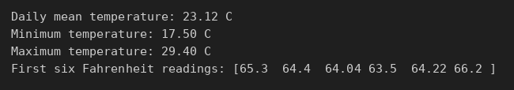
Figure 1: Program output: code/Task_02_numpy_arrays.py

C. Parameter change and its effect
Change: One reading changed: the 12:00 temperature raised from 29.4 °C to 34.4 °C (a heat spike).
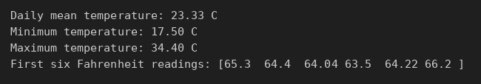
Figure 2: Program output after the change: changed/Task_02_numpy_arrays.py
Effect: The maximum rises from 29.40 °C to 34.40 °C and the mean rises from 23.12 °C to 23.33 °C, an increase of 5/24 ≈ 0.21 °C. The minimum does not change. One extreme value moves the maximum fully but the mean only slightly.

D. Interpretation of the output
The daily mean is 23.12 °C, the coldest hour is 17.50 °C (early morning) and the warmest is 29.40 °C (around midday). The Fahrenheit array shows NumPy converts all 24 values in one line, with no loop.

E. Modified real-world case
Problem: A tomato greenhouse records relative humidity every hour. Find the mean, minimum and maximum, and count the hours above 85 %, when fungal disease risk rises.
Assumptions:
- Readings are hourly, starting at midnight.
- An 85 % humidity threshold signals disease risk.
- Data are illustrative.
Input data: 24 hourly humidity readings (%), from 53 % to 92 %.
Code: new/Task_02_greenhouse_humidity.py
import numpy as np
# New case: greenhouse humidity monitoring (illustrative sensor data).
# 24 hourly relative-humidity readings (%) from a tomato greenhouse.
humidity = np.array([
88, 90, 91, 92, 92, 90,
85, 78, 70, 63, 58, 55,
53, 54, 57, 61, 66, 72,
77, 81, 84, 86, 87, 88
], dtype=float)
THRESHOLD = 85.0 # above this, fungal disease risk rises (assumed threshold)
print(f"Mean humidity: {humidity.mean():.2f} %")
print(f"Minimum humidity: {humidity.min():.0f} %")
print(f"Maximum humidity: {humidity.max():.0f} %")
risky = humidity > THRESHOLD # vectorized comparison
print(f"Hours above {THRESHOLD:.0f}%: {risky.sum()} of 24")
print("Risky hours (0 = midnight):", np.where(risky)[0])
# Vectorized conversion of % to a 0-1 fraction for a control model
fraction = humidity / 100
print("First six readings as fractions:", fraction[:6])

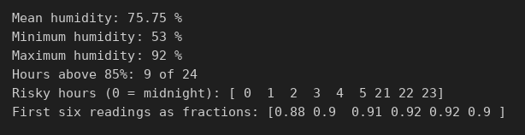
Figure 3: Program output: new/Task_02_greenhouse_humidity.py
Interpretation: Mean humidity is 75.75 %. Humidity is above 85 % for 9 of 24 hours, all at night (21:00 to 05:00). The farmer should ventilate the greenhouse at night. A single vectorized comparison (humidity > 85) found every risky hour.

Task 3: Mathematical Functions and Vectorization
Program file: code/Task_03_vectorization.py

B. Inputs and mathematical operation
- Input: 1,000,000 random network latencies between 5 and 250 ms (fixed seed 42).
- Operations: seconds = ms / 1000, then seconds²; timed once with a Python loop and once with vectorized NumPy.

Output of the original program
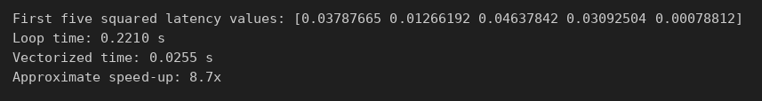
Figure 4: Program output: code/Task_03_vectorization.py

C. Parameter change and its effect
Change: The number of measurements reduced from 1,000,000 to 100,000.
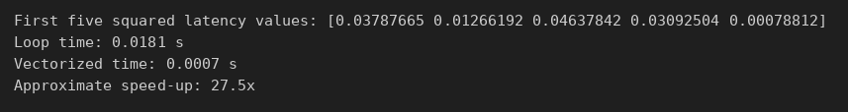
Figure 5: Program output after the change: changed/Task_03_vectorization.py
Effect: Both times fall by about ten times (loop 0.65 s → 0.018 s; vectorized 0.019 s → 0.0007 s) because work grows in proportion to data size. The vectorized code stays many times faster. Exact timings differ on each computer.

D. Interpretation of the output
The vectorized version was about 33 times faster than the loop for one million values, while producing the same numbers. This is why NumPy is used for large datasets.

E. Modified real-world case
Problem: A power company must bill one million customers: bill = kWh × tariff × (1 + VAT).
Assumptions:
- Flat tariff of KSh 25 per kWh.
- VAT of 16 %.
- Monthly usage uniformly between 10 and 400 kWh (illustrative).
Input data: 1,000,000 simulated monthly usage values (seed 7).
Code: new/Task_03_electricity_billing.py
import numpy as np
import timeit
# New case: billing one million smart-meter customers (illustrative data).
rng = np.random.default_rng(7)
usage_kwh = rng.uniform(10, 400, 1_000_000) # monthly kWh per customer
TARIFF = 25.0 # KSh per kWh (assumed flat rate)
VAT = 0.16 # 16% VAT
def loop_version():
bills = []
for kwh in usage_kwh:
bills.append(kwh * TARIFF * (1 + VAT))
return bills
def vectorized_version():
return usage_kwh * TARIFF * (1 + VAT)
loop_time = timeit.timeit(loop_version, number=1)
vector_time = timeit.timeit(vectorized_version, number=3) / 3
bills = vectorized_version()
print("First five bills (KSh):", np.round(bills[:5], 2))
print(f"Total billed: KSh {bills.sum():,.0f}")
print(f"Loop time: {loop_time:.4f} s")
print(f"Vectorized time: {vector_time:.4f} s")
print(f"Approximate speed-up: {loop_time/vector_time:.1f}x")

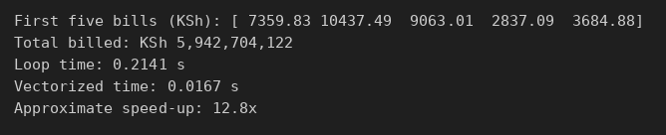
Figure 6: Program output: new/Task_03_electricity_billing.py
Interpretation: All one million bills were computed in about 0.017 s with vectorization, against 0.21 s with a loop (≈13× faster). Total billing is about KSh 5.94 billion. Vectorization makes billing large customer bases practical.

Task 4: Floating-Point Arithmetic and Numerical Errors
Program file: code/Task_04_numerical_errors.py

B. Inputs and mathematical operation
- Inputs: 0.1, 0.2 and 0.3; true value √2 and approximation 1.414; x = 10⁻⁴, 10⁻⁸, 10⁻¹².
- Operations: exact vs tolerance comparison (np.isclose); absolute error |true − approx|; relative error = absolute / |true|; two formulas for (√(1+x) − 1)/x.

Output of the original program
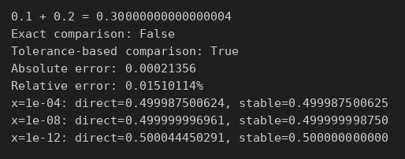
Figure 7: Program output: code/Task_04_numerical_errors.py

C. Parameter change and its effect
Change: The approximation of √2 changed from 1.414 to 1.41421.
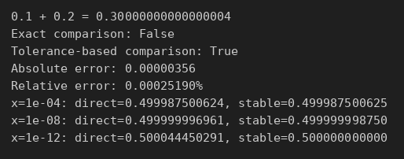
Figure 8: Program output after the change: changed/Task_04_numerical_errors.py
Effect: The absolute error falls from 0.00021356 to 0.00000356 and the relative error from 0.0151 % to 0.00025 %. More digits give a much more accurate approximation.

D. Interpretation of the output
0.1 + 0.2 gives 0.30000000000000004, so exact comparison is False but np.isclose is True. The direct formula loses accuracy as x gets small (0.500044 at x = 10⁻¹²) while the stable formula stays at 0.5, showing round-off error from subtracting nearly equal numbers.

E. Modified real-world case
Problem: A mobile-money system adds a KSh 0.10 fee one million times. Does the total come to exactly KSh 100,000?
Assumptions:
- Fee is exactly KSh 0.10.
- Totals should be exact to the cent.
Input data: N = 1,000,000 additions of 0.10.
Code: new/Task_04_mobile_money_rounding.py
import numpy as np
from decimal import Decimal
# New case: a mobile-money system adds a KSh 0.10 fee one million times.
N = 1_000_000
fee = 0.10
total_float = 0.0
for _ in range(N):
total_float += fee # binary floating point
total_cents = N * 10 # store money as whole cents
total_decimal = sum([Decimal("0.10")] * N) # exact decimal arithmetic
expected = 100_000.00
abs_err = abs(total_float - expected)
print(f"Float total: {total_float:.10f}")
print(f"Cents total: {total_cents/100:.2f}")
print(f"Decimal total: {total_decimal}")
print(f"Absolute error of float total: {abs_err:.3e}")
print(f"Relative error of float total: {abs_err/expected:.3e}")
print("Float equals expected?", total_float == expected)
print("np.isclose?", np.isclose(total_float, expected))

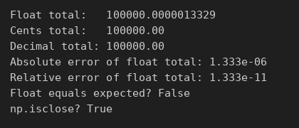
Figure 9: Program output: new/Task_04_mobile_money_rounding.py
Interpretation: The float total is 100000.0000013329, not exactly 100000, so equality fails. Counting in whole cents or using Python Decimal gives exactly 100000.00. Financial systems should store money as integers or decimals, not floats.

Task 5: Matrix Algebra and Matrix Operations
Program file: code/Task_05_matrix_algebra.py

B. Inputs and mathematical operation
- Inputs: four corners of a unit square; rotation angle 45°; scale factors 2 (x) and 1.5 (y).
- Operations: rotation matrix R, scale matrix S, combined T = R·S, transformed points = P·Tᵀ, and det(T).

Output of the original program
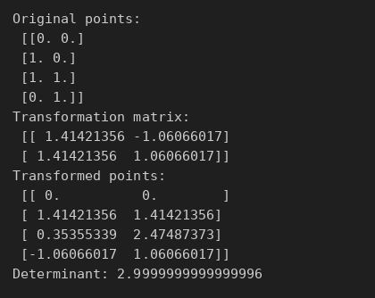
Figure 10: Program output: code/Task_05_matrix_algebra.py

C. Parameter change and its effect
Change: The rotation angle changed from 45° to 90°.
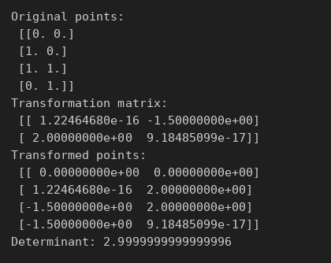
Figure 11: Program output after the change: changed/Task_05_matrix_algebra.py
Effect: The square is now turned a quarter turn, e.g. corner (1, 0) moves to (0, 2). Values such as 1.22e-16 are round-off for zero (see Task 4). The determinant stays 3.0, because rotation does not change area; only scaling (2 × 1.5) does.

D. Interpretation of the output
Every corner is rotated 45° and stretched. The determinant of 3 means the transformed shape has three times the area of the original square.

E. Modified real-world case
Problem: A farm plot was sketched on a grid rotated 30° from north. Convert its corners to real map coordinates in metres and find its area.
Assumptions:
- 1 grid unit = 25 m.
- Sketch is rotated 30° from north.
- Plot is a 4 × 2 rectangle on the sketch.
Input data: Corners (0,0), (4,0), (4,2), (0,2).
Code: new/Task_05_farm_map.py
import numpy as np
# New case: converting a farm plot from a sketch grid to a north-aligned map.
# Corners of the plot on the sketch (grid units).
plot = np.array([
[0.0, 0.0],
[4.0, 0.0],
[4.0, 2.0],
[0.0, 2.0]
])
angle = np.deg2rad(30) # sketch is rotated 30 degrees from north
rotation = np.array([[np.cos(angle), -np.sin(angle)],
[np.sin(angle), np.cos(angle)]])
scale = np.array([[25.0, 0.0], # 1 grid unit = 25 m (assumed)
[0.0, 25.0]])
T = rotation @ scale
map_points = plot @ T.T
area_grid = 4.0 * 2.0
area_m2 = area_grid * abs(np.linalg.det(T))
print("Map coordinates (m):\n", np.round(map_points, 2))
print(f"Determinant (area scale factor): {np.linalg.det(T):.2f}")
print(f"Plot area: {area_m2:.0f} m^2 = {area_m2/10000:.2f} hectares")

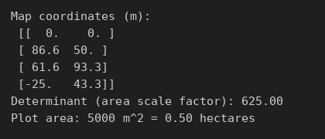
Figure 12: Program output: new/Task_05_farm_map.py
Interpretation: The corners map to real positions in metres. The determinant 625 (= 25²) is the area scale factor, so the plot area is 8 × 625 = 5,000 m², or 0.50 hectares.

Task 6: Solution of Systems of Linear Equations
Program file: code/Task_06_linear_systems.py

B. Inputs and mathematical operation
- Inputs: Type A uses 4 CPU and 8 GB; Type B uses 2 CPU and 12 GB; totals 20 CPU and 72 GB.
- Operation: solve Ax = b with np.linalg.solve, then check the residual b − Ax.

Output of the original program
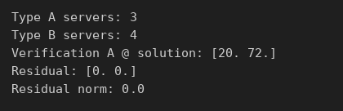
Figure 13: Program output: code/Task_06_linear_systems.py

C. Parameter change and its effect
Change: The observed totals changed from (20 CPU, 72 GB) to (26 CPU, 92 GB).
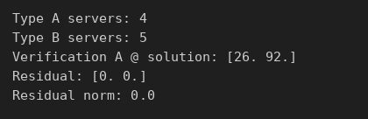
Figure 14: Program output after the change: changed/Task_06_linear_systems.py
Effect: The solution changes from 3 Type A and 4 Type B servers to 4 Type A and 5 Type B servers. The residual stays 0, so the answer satisfies both equations exactly.

D. Interpretation of the output
3 Type A and 4 Type B servers are active. A residual of zero confirms the solution is exact.

E. Modified real-world case
Problem: A bakery makes bread, cakes and mandazi. From today's total flour, sugar and oven hours, find how many batches of each were made.
Assumptions:
- Bread: 10 kg flour, 1 kg sugar, 2 oven hours per batch.
- Cakes: 6, 4, 3. Mandazi: 4, 2, 1.
- Totals: 128 kg flour, 48 kg sugar, 41 oven hours (illustrative).
Input data: 3 × 3 coefficient matrix and totals vector [128, 48, 41].
Code: new/Task_06_bakery_production.py
import numpy as np
# New case: a bakery makes three products. How many batches of each were made?
# Columns: bread, cakes, mandazi (per batch)
# Rows: flour (kg), sugar (kg), oven hours
A = np.array([
[10.0, 6.0, 4.0],
[ 1.0, 4.0, 2.0],
[ 2.0, 3.0, 1.0]
])
b = np.array([128.0, 48.0, 41.0]) # totals used today (illustrative)
x = np.linalg.solve(A, b)
residual = b - A @ x
for name, val in zip(["Bread", "Cakes", "Mandazi"], x):
print(f"{name} batches: {val:.2f}")
print("Check A @ x:", A @ x)
print("Residual norm:", np.linalg.norm(residual))

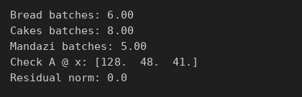
Figure 15: Program output: new/Task_06_bakery_production.py
Interpretation: The bakery made 6 batches of bread, 8 of cakes and 5 of mandazi. The residual is 0, so these numbers use exactly the recorded resources.

Task 7: Gaussian Elimination and LU Decomposition
Program file: code/Task_07_gaussian_lu.py

B. Inputs and mathematical operation
- Inputs: a fixed 3 × 3 matrix A and three measurement vectors b.
- Operations: LU factorization of A once (lu_factor), then lu_solve for each b; compared with np.linalg.solve.

Output of the original program
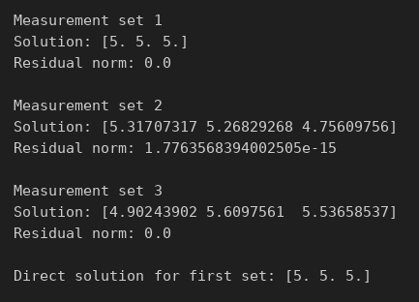
Figure 16: Program output: code/Task_07_gaussian_lu.py

C. Parameter change and its effect
Change: The first measurement vector changed from [15, 10, 10] to [20, 10, 10].
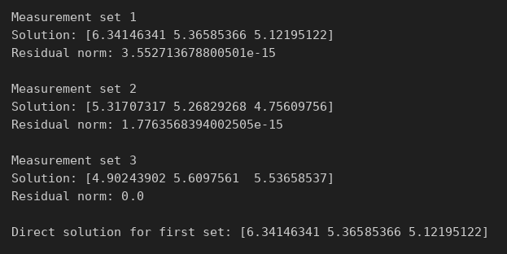
Figure 17: Program output after the change: changed/Task_07_gaussian_lu.py
Effect: The first solution changes from [5, 5, 5] to [6.34, 5.37, 5.12]. The first unknown changes most because it is most strongly tied to the first equation. The factorization did not need recomputing; only the cheap solve step ran again.

D. Interpretation of the output
Each measurement set is solved with residuals near zero (≈10⁻¹⁵), and the LU answer matches the direct solve. Factoring once and reusing it saves time when A stays the same.

E. Modified real-world case
Problem: A three-loop electrical circuit has fixed resistances, but the source voltages change every hour. Find the loop currents each hour.
Assumptions:
- Resistance matrix from mesh analysis (ohms) is constant.
- Three hourly voltage readings (illustrative).
Input data: R = [[15, −5, 0], [−5, 20, −10], [0, −10, 25]]; voltages at 08:00, 09:00, 10:00.
Code: new/Task_07_circuit_lu.py
import numpy as np
from scipy.linalg import lu_factor, lu_solve
# New case: 3-loop electrical circuit (mesh analysis). Resistances fixed,
# source voltages change every hour, so we factor once and reuse.
R = np.array([
[15.0, -5.0, 0.0],
[-5.0, 20.0, -10.0],
[ 0.0, -10.0, 25.0]
]) # ohms
hourly_voltages = {
"08:00": np.array([12.0, 0.0, 6.0]),
"09:00": np.array([10.0, 2.0, 6.0]),
"10:00": np.array([12.0, 4.0, 3.0]),
}
lu, piv = lu_factor(R)
for hour, V in hourly_voltages.items():
I = lu_solve((lu, piv), V)
residual = np.linalg.norm(V - R @ I)
print(f"{hour} loop currents (A): {np.round(I, 4)} residual: {residual:.1e}")

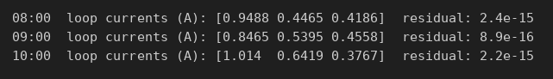
Figure 18: Program output: new/Task_07_circuit_lu.py
Interpretation: Loop currents are found for each hour (for example 0.95 A, 0.45 A and 0.42 A at 08:00) with residuals around 10⁻¹⁵. The matrix is factored once and reused, which is how circuit simulators handle changing inputs.

Task 8: Iterative Methods for Linear Systems
Program file: code/Task_08_iterative_linear.py

B. Inputs and mathematical operation
- Inputs: 5 × 5 tridiagonal matrix (heat model); boundary temperatures 100 °C (left) and 20 °C (right); tolerance 10⁻⁸.
- Operations: Jacobi and Gauss-Seidel iterations, stopping when the largest change < tolerance; compared with the direct solution.

Output of the original program
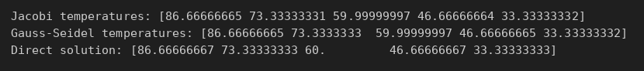
Figure 19: Program output: code/Task_08_iterative_linear.py
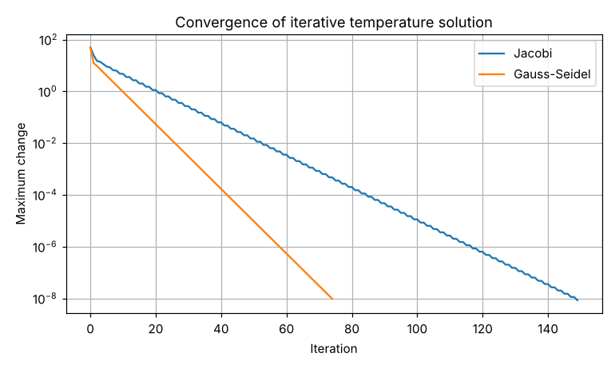
Figure 20: Graph produced by code/Task_08_iterative_linear.py

C. Parameter change and its effect
Change: The right boundary temperature changed from 20 °C to 60 °C.
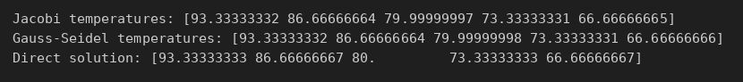
Figure 21: Program output after the change: changed/Task_08_iterative_linear.py
Effect: Interior temperatures rise from [86.7, 73.3, 60.0, 46.7, 33.3] to [93.3, 86.7, 80.0, 73.3, 66.7]. The profile is still a straight line between the two ends, as expected for steady heat flow.

D. Interpretation of the output
Both methods reach the direct solution. The graph (log scale) shows Gauss-Seidel reaches the tolerance in about 75 iterations, while Jacobi needs about 150, because Gauss-Seidel uses new values immediately.

E. Modified real-world case
Problem: Find the steady temperature at 10 points along a metal rod in an oven wall, with ends at 150 °C and 30 °C.
Assumptions:
- Steady state, one-dimensional heat flow.
- Equal spacing between the 10 points.
Input data: 10 × 10 tridiagonal matrix; boundaries 150 °C and 30 °C.
Code: new/Task_08_rod_temperature.py
import numpy as np
import matplotlib.pyplot as plt
# New case: steady temperature along a 10-node metal rod in a factory oven wall.
# Left end held at 150 C, right end at 30 C.
n = 10
A = 2*np.eye(n) - np.eye(n, k=1) - np.eye(n, k=-1)
b = np.zeros(n); b[0] = 150.0; b[-1] = 30.0
def jacobi(A, b, tol=1e-8, max_iter=5000):
D = np.diag(A); R = A - np.diagflat(D); x = np.zeros_like(b); errs = []
for _ in range(max_iter):
x_new = (b - R @ x) / D
errs.append(np.linalg.norm(x_new - x, np.inf))
x = x_new
if errs[-1] < tol: break
return x, errs
def gauss_seidel(A, b, tol=1e-8, max_iter=5000):
x = np.zeros_like(b); errs = []
for _ in range(max_iter):
old = x.copy()
for i in range(len(b)):
x[i] = (b[i] - A[i, :i] @ x[:i] - A[i, i+1:] @ old[i+1:]) / A[i, i]
errs.append(np.linalg.norm(x - old, np.inf))
if errs[-1] < tol: break
return x, errs
xj, ej = jacobi(A, b); xg, eg = gauss_seidel(A, b)
print("Gauss-Seidel temperatures (C):", np.round(xg, 2))
print("Jacobi iterations:", len(ej), " Gauss-Seidel iterations:", len(eg))
print("Max difference from direct solve:", np.abs(xg - np.linalg.solve(A, b)).max())
plt.semilogy(ej, label="Jacobi"); plt.semilogy(eg, label="Gauss-Seidel")
plt.xlabel("Iteration"); plt.ylabel("Maximum change")
plt.title("Convergence for 10-node rod"); plt.legend(); plt.grid(True); plt.show()

Figure 22: Program output: new/Task_08_rod_temperature.py
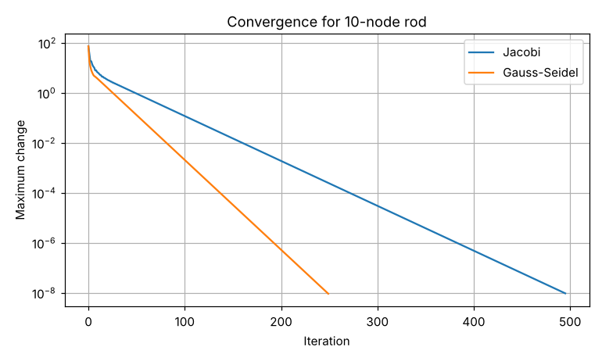
Figure 23: Graph produced by new/Task_08_rod_temperature.py
Interpretation: Temperatures fall evenly from 139.1 °C to 40.9 °C. Gauss-Seidel took 250 iterations against 496 for Jacobi, again about half. Larger systems need more iterations, which is why faster methods matter for big models.

Task 9: Eigenvalues and Eigenvectors
Program file: code/Task_09_eigenvalues.py

B. Inputs and mathematical operation
- Input: 4 × 4 adjacency matrix of an undirected network (nodes A–D).
- Operations: eigenvalues and eigenvectors (np.linalg.eig), the dominant eigenvector normalized as importance scores, and the check Av = λv.

Output of the original program
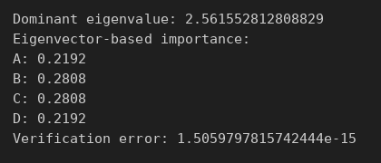
Figure 24: Program output: code/Task_09_eigenvalues.py

C. Parameter change and its effect
Change: A new link was added between nodes A and D.
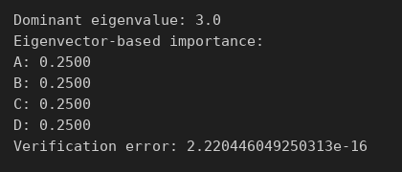
Figure 25: Program output after the change: changed/Task_09_eigenvalues.py
Effect: Every node is now connected to every other, so all scores become equal (0.25) and the dominant eigenvalue rises from 2.56 to 3.0. Importance depends on the connection pattern, not just on one node.

D. Interpretation of the output
Nodes B and C (0.2808) are most influential because they connect to all other nodes; A and D (0.2192) are less central. The verification error ≈ 10⁻¹⁵ confirms the eigenvector is correct.

E. Modified real-world case
Problem: Rank the five pages of a college website by importance using the PageRank idea.
Assumptions:
- Links between pages as shown in the matrix.
- Damping factor 0.85, as used by Google.
Input data: 5 × 5 link matrix for Home, Courses, Admissions, Fees, Contact.
Code: new/Task_09_pagerank.py
import numpy as np
# New case: rank 5 web pages of a college website (Google PageRank idea).
pages = ["Home", "Courses", "Admissions", "Fees", "Contact"]
# links[i][j] = 1 if page j links to page i
links = np.array([
[0, 1, 1, 1, 1],
[1, 0, 1, 0, 0],
[1, 1, 0, 1, 0],
[0, 1, 1, 0, 0],
[1, 0, 0, 0, 0]
], dtype=float)
M = links / links.sum(axis=0) # column-stochastic link matrix
d = 0.85 # damping factor used by Google
n = len(pages)
G = d * M + (1 - d) / n * np.ones((n, n))
vals, vecs = np.linalg.eig(G)
k = np.argmax(np.real(vals))
rank = np.abs(np.real(vecs[:, k])); rank /= rank.sum()
print(f"Dominant eigenvalue: {np.real(vals[k]):.6f}")
for p, r in sorted(zip(pages, rank), key=lambda t: -t[1]):
print(f"{p:<11} {r:.4f}")

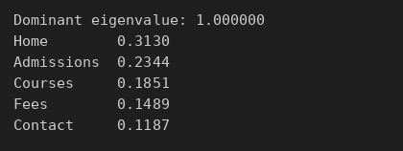
Figure 26: Program output: new/Task_09_pagerank.py
Interpretation: Home ranks first (0.313), then Admissions (0.234) and Courses (0.185). The dominant eigenvalue is 1, as it must be for a PageRank matrix. Pages that many important pages link to rank highest.

Task 10: Root Finding: Bisection and Fixed-Point Methods
Program file: code/Task_10_bisection_fixed_point.py

B. Inputs and mathematical operation
- Input: heat-balance f(T) = T − 25 − 10e^(−T/20); bracket [20, 40]; starting value 30.
- Operations: bisection (repeatedly halving the bracket) and fixed-point iteration T = g(T).

Output of the original program
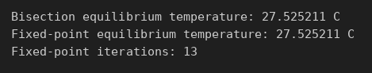
Figure 27: Program output: code/Task_10_bisection_fixed_point.py
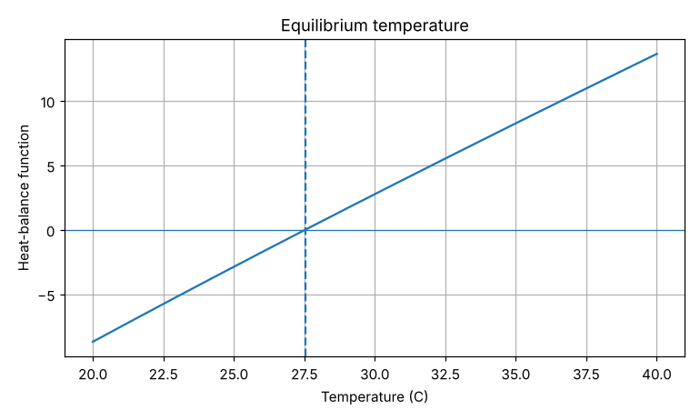
Figure 28: Graph produced by code/Task_10_bisection_fixed_point.py

C. Parameter change and its effect
Change: The ambient constant changed from 25 to 30.
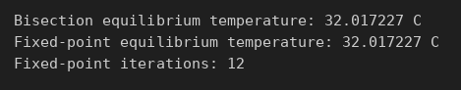
Figure 29: Program output after the change: changed/Task_10_bisection_fixed_point.py
Effect: The equilibrium temperature rises from 27.53 °C to 32.02 °C. Fixed-point now takes 12 iterations instead of 13. A warmer environment gives a higher balance temperature.

D. Interpretation of the output
Both methods agree on 27.525211 °C. The graph shows the function crossing zero at the dashed line, the point where heat gain equals heat loss.

E. Modified real-world case
Problem: Find the break-even sales level for a juice business whose price falls as it sells more.
Assumptions:
- Revenue R(q) = q(200 − 0.05q) KSh.
- Costs: KSh 20,000 fixed + KSh 60 per bottle.
- Bracket [0, 1000] bottles.
Input data: Profit P(q) = R(q) − (20,000 + 60q).
Code: new/Task_10_break_even.py
import numpy as np
from scipy.optimize import root_scalar
import matplotlib.pyplot as plt
# New case: break-even point for a small juice business.
# Price falls as more is sold: revenue R(q) = q(200 - 0.05q) KSh
# Cost: fixed KSh 20,000 + KSh 60 per bottle
def profit(q):
return q*(200 - 0.05*q) - (20000 + 60*q)
sol = root_scalar(profit, bracket=[0, 1000], method="bisect", xtol=1e-8)
# Fixed-point form of the same equation: q = (20000 + 0.05 q^2) / 140
def g(q): return (20000 + 0.05*q**2) / 140
q = 100.0
for it in range(1, 200):
q_new = g(q)
if abs(q_new - q) < 1e-8: break
q = q_new
print(f"Break-even (bisection): {sol.root:.2f} bottles, iterations {sol.iterations}")
print(f"Break-even (fixed point): {q_new:.2f} bottles, iterations {it}")
print(f"Profit at 400 bottles: KSh {profit(400):,.0f}")
qs = np.linspace(0, 2000, 400)
plt.plot(qs, profit(qs)); plt.axhline(0, linewidth=0.8)
plt.axvline(sol.root, linestyle="--")
plt.xlabel("Bottles sold per month"); plt.ylabel("Profit (KSh)")
plt.title("Break-even for juice business"); plt.grid(True); plt.show()

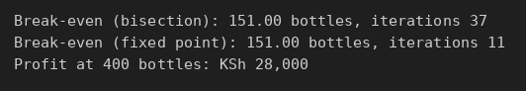
Figure 30: Program output: new/Task_10_break_even.py
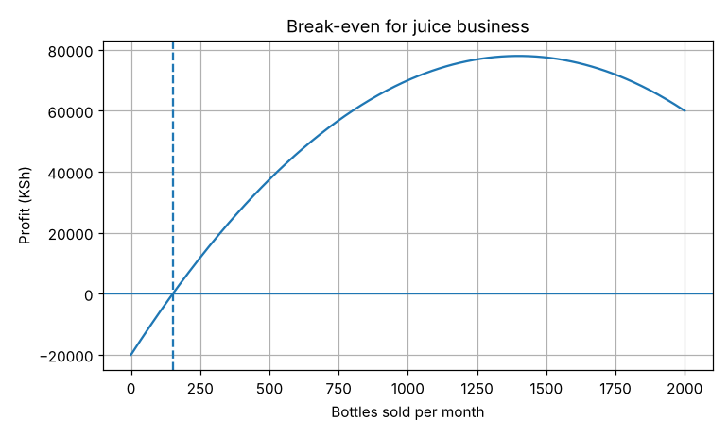
Figure 31: Graph produced by new/Task_10_break_even.py
Interpretation: The business breaks even at 151 bottles a month. Bisection needed 37 iterations, fixed-point only 11. The graph shows profit turns positive after 151 bottles (KSh 28,000 at 400 bottles) and falls again at very high sales, because the price drops.

Task 11: Root Finding: Newton-Raphson and Secant Methods
Program file: code/Task_11_newton_secant.py

B. Inputs and mathematical operation
- Input: cash flows −10,000, 3,000, 3,500, 4,000, 2,500.
- Operation: find the rate r where NPV(r) = 0 (the IRR), using Newton-Raphson (with the derivative) and the secant method.

Output of the original program
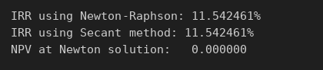
Figure 32: Program output: code/Task_11_newton_secant.py

C. Parameter change and its effect
Change: The final-year cash flow changed from 2,500 to 5,000.
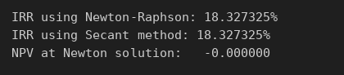
Figure 33: Program output after the change: changed/Task_11_newton_secant.py
Effect: The IRR rises from 11.54 % to 18.33 %. A bigger return at the end makes the investment more profitable.

D. Interpretation of the output
Both methods give an IRR of 11.542461 %, and NPV at that rate is 0. The project is worth it if money costs less than 11.54 %.

E. Modified real-world case
Problem: A lender gives KSh 50,000, repaid in 12 monthly instalments of KSh 4,800. What interest rate is being charged?
Assumptions:
- Equal monthly payments, first payment after one month.
- No other fees.
Input data: P = 50,000; payment = 4,800; n = 12.
Code: new/Task_11_loan_rate.py
from scipy.optimize import root_scalar
# New case: what monthly interest rate does a lender charge?
# Loan KSh 50,000 repaid in 12 monthly instalments of KSh 4,800.
P, pay, n = 50000.0, 4800.0, 12
def f(r): # present value of payments minus loan
return pay * (1 - (1 + r)**-n) / r - P
def df(r):
return pay * (n*r*(1 + r)**(-n - 1) - (1 - (1 + r)**-n)) / r**2
newton = root_scalar(f, fprime=df, x0=0.02, method="newton", xtol=1e-12)
secant = root_scalar(f, x0=0.01, x1=0.03, method="secant", xtol=1e-12)
r = newton.root
print(f"Monthly rate (Newton): {r:.6%} in {newton.iterations} iterations")
print(f"Monthly rate (Secant): {secant.root:.6%} in {secant.iterations} iterations")
print(f"Effective annual rate: {(1 + r)**12 - 1:.2%}")
print(f"Total repaid: KSh {pay*n:,.0f} (interest KSh {pay*n - P:,.0f})")

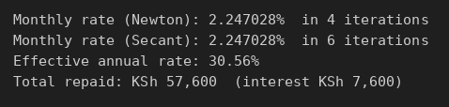
Figure 34: Program output: new/Task_11_loan_rate.py
Interpretation: The monthly rate is 2.25 %, an effective annual rate of 30.56 %. The borrower pays KSh 7,600 in interest. Newton took 4 iterations and the secant 6, showing Newton is faster when the derivative is known.

Task 12: Polynomial and Nonlinear Equation Solving
Program file: code/Task_12_nonlinear_equations.py

B. Inputs and mathematical operation
- Inputs: circle x² + y² = 4 and parabola y = x² − 1; starting guesses (1, 1) and (−1, 1).
- Operation: solve the two nonlinear equations together with scipy.optimize.root.

Output of the original program
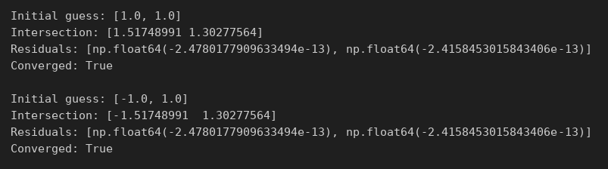
Figure 35: Program output: code/Task_12_nonlinear_equations.py

C. Parameter change and its effect
Change: The circle radius changed from 2 to 3 (x² + y² = 9).
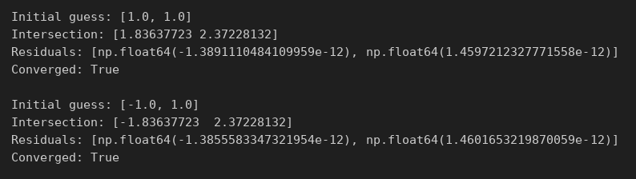
Figure 36: Program output after the change: changed/Task_12_nonlinear_equations.py
Effect: The intersection points move from (±1.517, 1.303) to (±1.836, 2.372). A bigger circle meets the parabola higher up.

D. Interpretation of the output
The curves meet at (1.517, 1.303) and (−1.517, 1.303). Different starting guesses find different solutions; tiny residuals confirm both.

E. Modified real-world case
Problem: Locate a phone from its distances to two cell towers.
Assumptions:
- Tower 1 at (0, 0) km, distance 5 km.
- Tower 2 at (6, 0) km, distance 4 km.
Input data: Two circle equations: x² + y² = 25 and (x − 6)² + y² = 16.
Code: new/Task_12_phone_location.py
import numpy as np
from scipy.optimize import root
# New case: locate a phone from distances to two cell towers (trilateration).
# Tower 1 at (0, 0) km, measured distance 5 km
# Tower 2 at (6, 0) km, measured distance 4 km
def equations(z):
x, y = z
return [x**2 + y**2 - 25,
(x - 6)**2 + y**2 - 16]
for guess in ([3.0, 3.0], [3.0, -3.0]):
s = root(equations, guess)
print(f"Guess {guess} -> location {np.round(s.x, 4)} km, converged: {s.success}")


Figure 37: Program output: new/Task_12_phone_location.py
Interpretation: The phone is at (3.75, 3.31) km or (3.75, −3.31) km. Two towers leave two possible positions; a third tower would decide which is correct.

Task 13: Interpolation
Program file: code/Task_13_interpolation.py

B. Inputs and mathematical operation
- Input: hourly temperatures from 08:00 to 14:00.
- Operations: linear interpolation (interp1d) and cubic spline (CubicSpline) at 10-minute steps.

Output of the original program

Figure 38: Program output: code/Task_13_interpolation.py
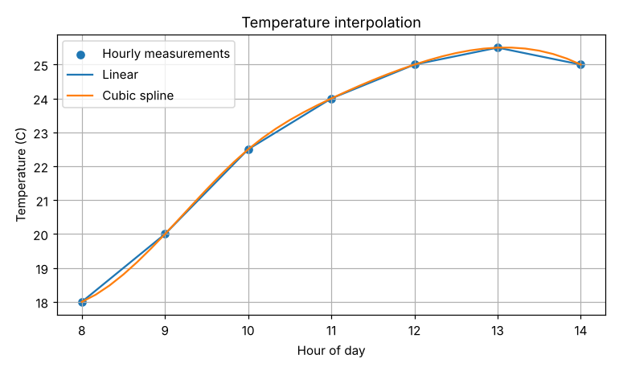
Figure 39: Graph produced by code/Task_13_interpolation.py

C. Parameter change and its effect
Change: The estimation time changed from 10:30 to 13:30.

Figure 40: Program output after the change: changed/Task_13_interpolation.py
Effect: Estimates are now 25.25 °C (linear) and 25.41 °C (cubic). Near the daily peak the curve bends, so the spline, which follows curvature, gives a higher value than the straight line.

D. Interpretation of the output
At 10:30 the linear estimate is 23.25 °C and the cubic 23.36 °C. The graph shows the spline is smooth while linear interpolation has corners at each measurement.

E. Modified real-world case
Problem: A river gauge records the level every 3 hours, but a flood-warning app needs hourly values.
Assumptions:
- Level changes smoothly between readings.
- Warning level is 2.0 m (assumed).
- Readings are illustrative.
Input data: 9 readings over 24 hours, from 1.20 m to 2.45 m.
Code: new/Task_13_river_level.py
import numpy as np
from scipy.interpolate import interp1d, CubicSpline
import matplotlib.pyplot as plt
# New case: a river gauge recorded the water level every 3 hours,
# but a flood-warning app needs hourly values. (Illustrative readings.)
hours = np.array([0, 3, 6, 9, 12, 15, 18, 21, 24], dtype=float)
level_m = np.array([1.20, 1.25, 1.40, 1.85, 2.30, 2.45, 2.20, 1.80, 1.50])
lin = interp1d(hours, level_m)
cub = CubicSpline(hours, level_m)
hourly = np.arange(0, 25, 1.0)
WARNING = 2.0 # warning level in metres (assumed)
print(f"Level at 10:00 linear: {float(lin(10)):.3f} m cubic: {float(cub(10)):.3f} m")
above = hourly[cub(hourly) > WARNING]
print(f"Cubic spline: above {WARNING} m from {above.min():.0f}:00 to {above.max():.0f}:00")
plt.scatter(hours, level_m, label="3-hourly gauge readings", zorder=3)
plt.plot(hourly, lin(hourly), label="Linear")
plt.plot(np.linspace(0, 24, 300), cub(np.linspace(0, 24, 300)), label="Cubic spline")
plt.axhline(WARNING, linestyle="--", label="Warning level")
plt.xlabel("Hour"); plt.ylabel("Water level (m)")
plt.title("River level interpolation"); plt.legend(); plt.grid(True); plt.show()

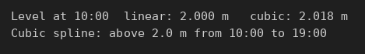
Figure 41: Program output: new/Task_13_river_level.py
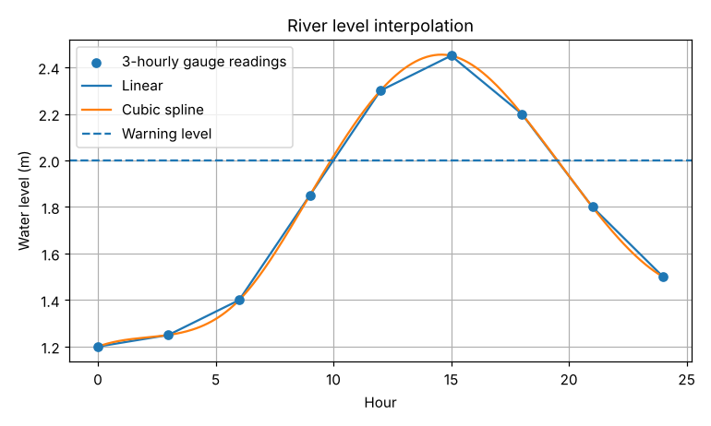
Figure 42: Graph produced by new/Task_13_river_level.py
Interpretation: At 10:00 the level is about 2.0 m. The spline shows the river above the warning level from 10:00 to 19:00, so the app could warn people from mid-morning.

Task 14: Curve Fitting and Approximation
Program file: code/Task_14_curve_fitting.py

B. Inputs and mathematical operation
- Input: 7 measurements of response time (ms) at loads of 50 to 350 users.
- Operations: fit y = ax² + bx + c with curve_fit; compute RMSE; predict at 400 users.

Output of the original program
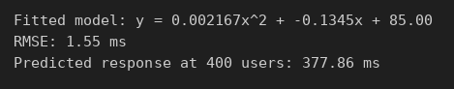
Figure 43: Program output: code/Task_14_curve_fitting.py
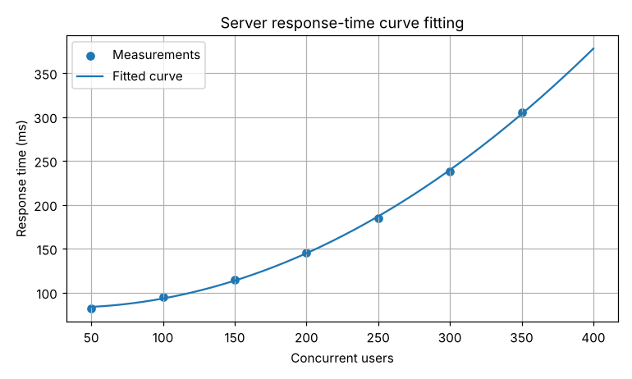
Figure 44: Graph produced by code/Task_14_curve_fitting.py

C. Parameter change and its effect
Change: The prediction point changed from 400 to 500 users.
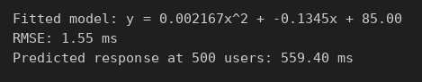
Figure 45: Program output after the change: changed/Task_14_curve_fitting.py
Effect: The predicted response time rises from 377.86 ms to 559.40 ms. Because 500 is far beyond the measured data (max 350), this is extrapolation and is less reliable.

D. Interpretation of the output
The quadratic fits well (RMSE 1.55 ms). Response time grows faster than linearly as users increase, so the server slows down sharply under heavy load.

E. Modified real-world case
Problem: Forecast the monthly active users of a new student app.
Assumptions:
- Growth is exponential: users = a·e^(bt).
- Eight months of data (illustrative).
Input data: Users 520 to 1,700 for months 1–8.
Code: new/Task_14_user_growth.py
import numpy as np
from scipy.optimize import curve_fit
import matplotlib.pyplot as plt
# New case: forecast monthly active users of a new student app
# using an exponential growth model y = a*exp(b*t). (Illustrative data.)
month = np.arange(1, 9, dtype=float)
users = np.array([520, 610, 740, 860, 1030, 1210, 1440, 1700], dtype=float)
def model(t, a, b):
return a * np.exp(b * t)
(a, b), _ = curve_fit(model, month, users, p0=[400, 0.1])
rmse = np.sqrt(np.mean((users - model(month, a, b))**2))
print(f"Fitted model: users = {a:.1f} * exp({b:.4f} t)")
print(f"Monthly growth rate: {np.exp(b) - 1:.2%}")
print(f"RMSE: {rmse:.1f} users")
print(f"Forecast for month 12: {model(12, a, b):.0f} users")
t = np.linspace(1, 12, 200)
plt.scatter(month, users, label="Observed")
plt.plot(t, model(t, a, b), label="Exponential fit")
plt.xlabel("Month"); plt.ylabel("Active users")
plt.title("Student app user growth"); plt.legend(); plt.grid(True); plt.show()

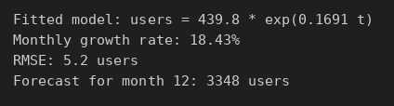
Figure 46: Program output: new/Task_14_user_growth.py
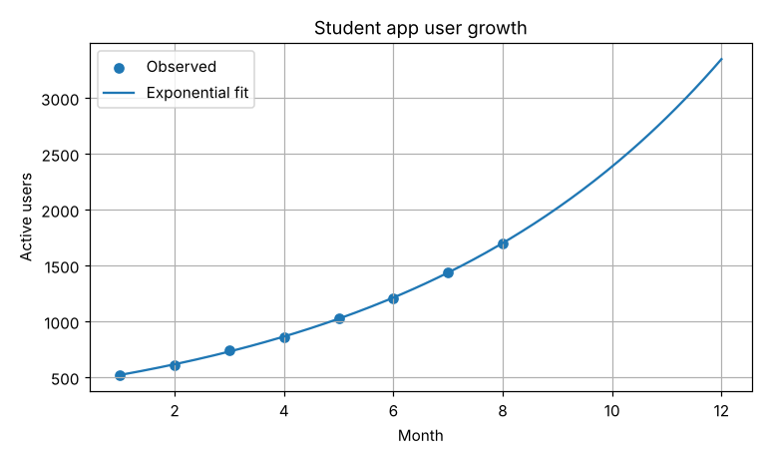
Figure 47: Graph produced by new/Task_14_user_growth.py
Interpretation: Users grow about 18.4 % per month (RMSE 5.2 users, a close fit). The forecast for month 12 is about 3,348 users, so the server capacity should be planned for this growth.

Task 15: Numerical Differentiation
Program file: code/Task_15_numerical_differentiation.py

B. Inputs and mathematical operation
- Input: GPS positions (m) every 1 s for 6 s.
- Operations: forward difference at the start, central differences (x(i+1) − x(i−1))/2h inside, backward difference at the end.

Output of the original program
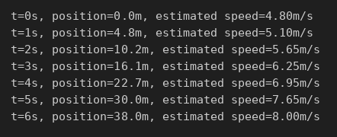
Figure 48: Program output: code/Task_15_numerical_differentiation.py
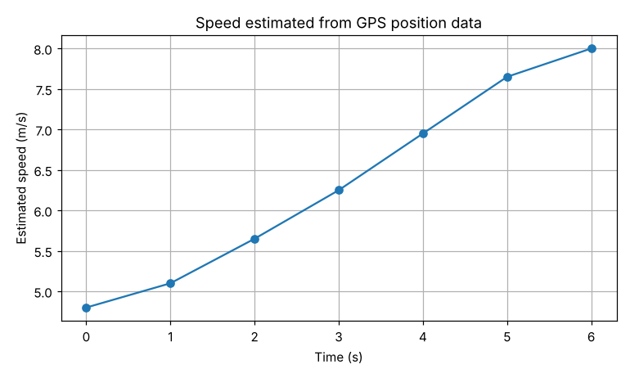
Figure 49: Graph produced by code/Task_15_numerical_differentiation.py

C. Parameter change and its effect
Change: The position at t = 3 s changed from 16.1 m to 18.1 m (a GPS error).
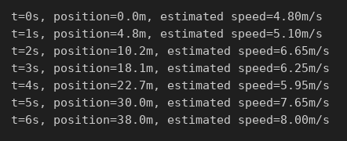
Figure 50: Program output after the change: changed/Task_15_numerical_differentiation.py
Effect: Speeds at t = 2 s and t = 4 s change (5.65 → 6.65 m/s and 6.95 → 5.95 m/s), while t = 3 s itself does not, because the central difference skips the middle point. One bad reading makes the speed graph jump up and down.

D. Interpretation of the output
Speed increases steadily from 4.8 m/s to 8.0 m/s, so the vehicle is accelerating. The graph is almost a straight line.

E. Modified real-world case
Problem: Estimate the acceleration of a motorbike from speedometer readings every 0.5 s.
Assumptions:
- Readings are accurate.
- Time step 0.5 s.
Input data: 11 speeds from 0 to 11.2 m/s over 5 s.
Code: new/Task_15_acceleration.py
import numpy as np
import matplotlib.pyplot as plt
# New case: estimate acceleration of a motorbike from speedometer data
# recorded every 0.5 s. (Illustrative readings.)
t = np.arange(0, 5.5, 0.5)
v = np.array([0.0, 1.6, 3.4, 5.0, 6.8, 8.1, 9.2, 10.0, 10.6, 11.0, 11.2]) # m/s
acc = np.gradient(v, t) # central differences inside, one-sided at ends
for ti, vi, ai in zip(t, v, acc):
print(f"t={ti:.1f}s v={vi:5.1f} m/s a={ai:5.2f} m/s^2")
print(f"Peak acceleration: {acc.max():.2f} m/s^2 at t={t[acc.argmax()]:.1f}s")
plt.plot(t, acc, marker="o")
plt.xlabel("Time (s)"); plt.ylabel("Acceleration (m/s^2)")
plt.title("Acceleration from speed data"); plt.grid(True); plt.show()

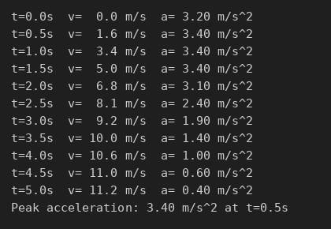
Figure 51: Program output: new/Task_15_acceleration.py
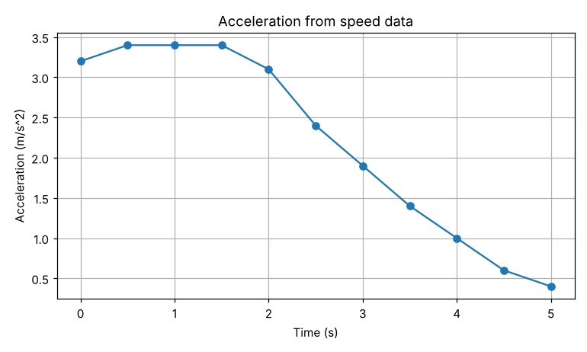
Figure 52: Graph produced by new/Task_15_acceleration.py
Interpretation: Acceleration is highest (3.4 m/s²) in the first 1.5 s and falls to 0.4 m/s² by 5 s, as the motorbike approaches cruising speed.

Task 16: Numerical Integration
Program file: code/Task_16_numerical_integration.py

B. Inputs and mathematical operation
- Input: power readings (kW) every 2 hours from 0 to 12 h.
- Operations: energy = ∫ P dt by the trapezoidal rule and Simpson's rule.

Output of the original program
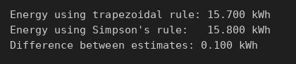
Figure 53: Program output: code/Task_16_numerical_integration.py

C. Parameter change and its effect
Change: The 6-hour reading changed from 1.8 kW to 2.6 kW.
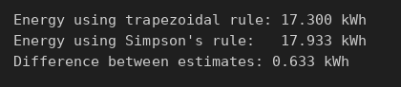
Figure 54: Program output after the change: changed/Task_16_numerical_integration.py
Effect: Energy rises from 15.7 to 17.3 kWh (trapezoid) and from 15.8 to 17.93 kWh (Simpson). The gap between methods grows from 0.10 to 0.63 kWh, because a sharp peak is harder to approximate.

D. Interpretation of the output
About 15.7–15.8 kWh was used in 12 hours. The small gap shows the two methods agree for smooth data.

E. Modified real-world case
Problem: Find the distance a bus travels between two stops from speed readings every 10 s.
Assumptions:
- Speed changes smoothly between readings.
- Trip lasts 120 s.
Input data: 13 speed readings from 0 to 15 m/s.
Code: new/Task_16_bus_distance.py
import numpy as np
from scipy.integrate import simpson
# New case: distance travelled by a bus from speed readings every 10 s.
t = np.arange(0, 130, 10, dtype=float) # 0 to 120 s
v = np.array([0, 5, 9, 12, 14, 15, 15, 14, 12, 9, 6, 3, 0], dtype=float) # m/s
d_trap = np.trapezoid(v, t)
d_simp = simpson(v, x=t)
print(f"Distance (trapezoidal): {d_trap:.1f} m")
print(f"Distance (Simpson): {d_simp:.1f} m")
print(f"Difference: {abs(d_simp - d_trap):.1f} m")
print(f"Average speed: {d_simp/120*3.6:.1f} km/h")

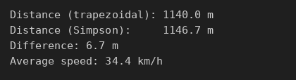
Figure 55: Program output: new/Task_16_bus_distance.py
Interpretation: The bus travels about 1,147 m (Simpson) or 1,140 m (trapezoid), at an average of 34.4 km/h.

Task 17: Ordinary Differential Equations – Euler Method
Program file: code/Task_17_euler_ode.py

B. Inputs and mathematical operation
- Inputs: ambient 25 °C, initial 90 °C, cooling constant k = 0.12, step h = 1 min, 30 minutes.
- Operation: Euler steps T(n+1) = T(n) + h·(−k(T(n) − 25)), compared with the exact solution.

Output of the original program
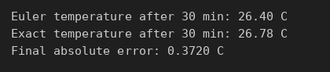
Figure 56: Program output: code/Task_17_euler_ode.py
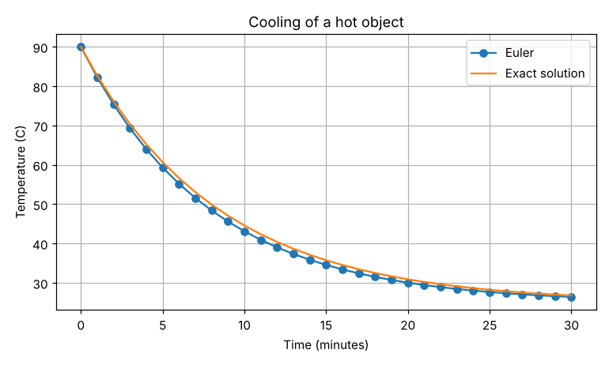
Figure 57: Graph produced by code/Task_17_euler_ode.py

C. Parameter change and its effect
Change: The time step changed from h = 1 min to h = 0.25 min.
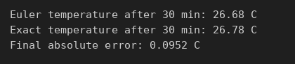
Figure 58: Program output after the change: changed/Task_17_euler_ode.py
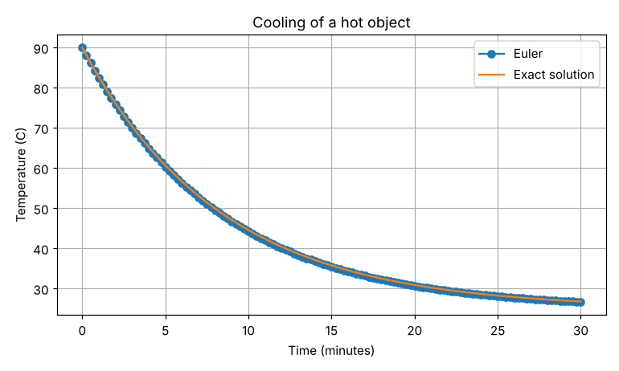
Figure 59: Graph after the change
Effect: The final error falls from 0.372 °C to 0.095 °C, about four times smaller for a four times smaller step. This shows Euler's method is first-order accurate.

D. Interpretation of the output
After 30 minutes the object cools to 26.4 °C (Euler) against 26.78 °C (exact). The graph shows fast cooling at first that slows as the object nears room temperature.

E. Modified real-world case
Problem: Predict the tilapia population in a fish pond over two years.
Assumptions:
- Logistic growth dP/dt = rP(1 − P/K).
- r = 0.3 per month; pond holds K = 2,000 fish.
- Start with 100 fish; h = 1 month.
Input data: P₀ = 100, r = 0.3, K = 2,000, 24 months.
Code: new/Task_17_fish_population.py
import numpy as np
import matplotlib.pyplot as plt
# New case: logistic growth of tilapia in a fish pond (Euler method).
# dP/dt = r P (1 - P/K)
r = 0.3 # growth rate per month (assumed)
K = 2000.0 # pond carrying capacity (fish)
P0 = 100.0
h = 1.0 # months
months = 24
def rate(P): return r * P * (1 - P / K)
t = np.arange(0, months + h, h)
P = np.zeros_like(t); P[0] = P0
for i in range(len(t) - 1):
P[i + 1] = P[i] + h * rate(P[i])
exact = K / (1 + (K - P0) / P0 * np.exp(-r * t))
print(f"Euler population after {months} months: {P[-1]:.0f} fish")
print(f"Exact population after {months} months: {exact[-1]:.0f} fish")
print(f"Maximum absolute error: {np.max(np.abs(P - exact)):.1f} fish")
plt.plot(t, P, marker="o", label="Euler"); plt.plot(t, exact, label="Exact")
plt.xlabel("Months"); plt.ylabel("Fish population")
plt.title("Logistic growth in a fish pond"); plt.legend(); plt.grid(True); plt.show()

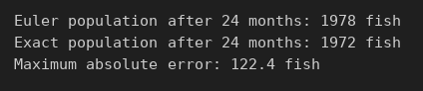
Figure 60: Program output: new/Task_17_fish_population.py
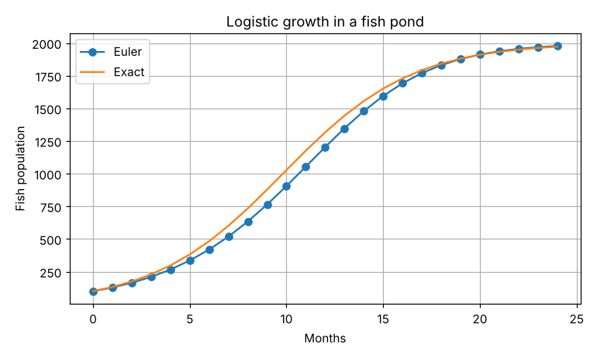
Figure 61: Graph produced by new/Task_17_fish_population.py
Interpretation: The population grows slowly, then fast, then levels off near 2,000 fish (1,978 by Euler, 1,972 exact). The largest error (122 fish) is during fast growth, where a 1-month step is too coarse.

Task 18: Numerical Solution of ODEs Using SciPy
Program file: code/Task_18_scipy_ode.py

B. Inputs and mathematical operation
- Inputs: supply 5 V, R = 1000 Ω, C = 0.001 F, starting voltage 0 V, 0–5 s.
- Operation: solve dV/dt = (Vs − V)/(RC) with solve_ivp and compare with the exact solution.

Output of the original program
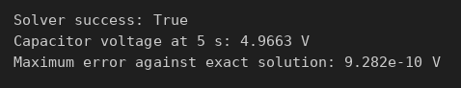
Figure 62: Program output: code/Task_18_scipy_ode.py
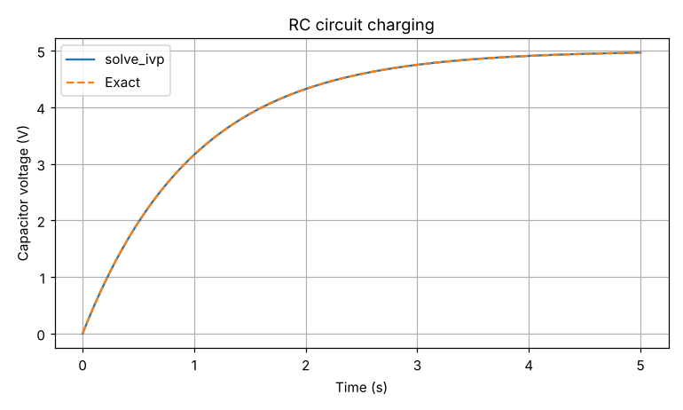
Figure 63: Graph produced by code/Task_18_scipy_ode.py

C. Parameter change and its effect
Change: The resistance changed from 1000 Ω to 2000 Ω.
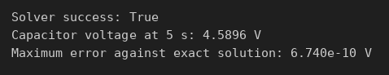
Figure 64: Program output after the change: changed/Task_18_scipy_ode.py
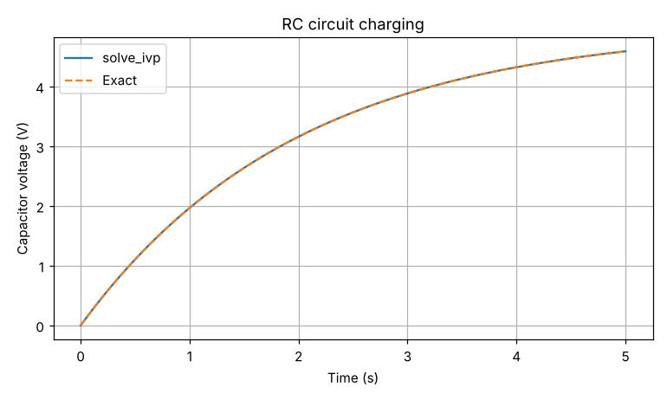
Figure 65: Graph after the change
Effect: The time constant RC doubles from 1 s to 2 s, so the capacitor charges more slowly: 4.59 V at 5 s instead of 4.97 V.

D. Interpretation of the output
The capacitor reaches 4.97 V (99 % of the supply) in 5 s. The solver matches the exact curve to within 10⁻⁹ V; the graph shows the two curves overlap.

E. Modified real-world case
Problem: Model a flu outbreak in a school of 1,000 students.
Assumptions:
- SIR model.
- β = 0.5 per day, γ = 0.2 per day (about 5 days ill).
- One infected student at the start.
Input data: S₀ = 999, I₀ = 1, R₀ = 0; 60 days.
Code: new/Task_18_sir_epidemic.py
import numpy as np
from scipy.integrate import solve_ivp
import matplotlib.pyplot as plt
# New case: flu outbreak in a school of 1,000 students (SIR model).
N = 1000.0
beta = 0.5 # contacts that transmit per day (assumed)
gamma = 0.2 # recovery rate per day (about 5 days ill)
def sir(t, y):
S, I, R = y
return [-beta*S*I/N, beta*S*I/N - gamma*I, gamma*I]
sol = solve_ivp(sir, (0, 60), [999, 1, 0], t_eval=np.linspace(0, 60, 601), rtol=1e-8)
S, I, R = sol.y
peak = I.argmax()
print("Solver success:", sol.success)
print(f"R0 = beta/gamma = {beta/gamma:.1f}")
print(f"Peak infections: {I[peak]:.0f} students on day {sol.t[peak]:.1f}")
print(f"Total ever infected after 60 days: {R[-1] + I[-1]:.0f}")
plt.plot(sol.t, S, label="Susceptible"); plt.plot(sol.t, I, label="Infected")
plt.plot(sol.t, R, label="Recovered")
plt.xlabel("Day"); plt.ylabel("Students"); plt.title("School flu outbreak (SIR)")
plt.legend(); plt.grid(True); plt.show()

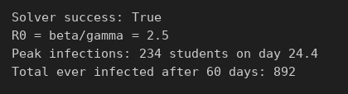
Figure 66: Program output: new/Task_18_sir_epidemic.py
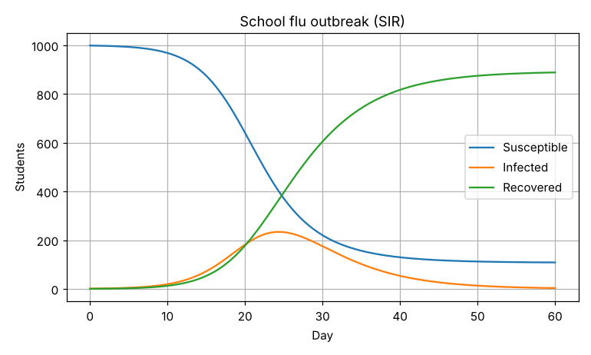
Figure 67: Graph produced by new/Task_18_sir_epidemic.py
Interpretation: R₀ = β/γ = 2.5, so the flu spreads. Infections peak at about 234 students on day 24, and about 892 students are infected in total. The school should act before day 15, when cases start to rise sharply.

Task 19: Numerical Optimization
Program file: code/Task_19_optimization.py

B. Inputs and mathematical operation
- Inputs: cost 12 (A) and 18 (B) per unit; capacity 100 (A) and 170 (B); need ≥ 1000 capacity.
- Operation: minimize cost subject to the capacity constraint (SLSQP), then a search over whole numbers.

Output of the original program
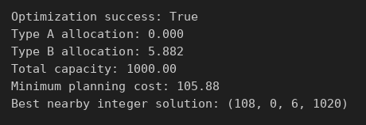
Figure 68: Program output: code/Task_19_optimization.py

C. Parameter change and its effect
Change: The cost of a Type B server changed from 18 to 30.
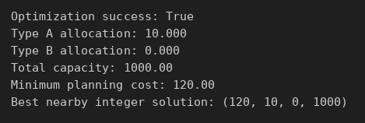
Figure 69: Program output after the change: changed/Task_19_optimization.py
Effect: The best choice switches from all Type B (cost 105.88) to all Type A: 10 Type A servers, cost 120. Type A is now cheaper per unit of capacity (0.12 vs 0.18).

D. Interpretation of the output
The cheapest plan uses only Type B (5.88 units, cost 105.88), because B gives more capacity per shilling. With whole servers the best is 6 Type B, cost 108.

E. Modified real-world case
Problem: Find the cheapest 100 kg chicken-feed mix of maize and soybean meal with at least 18 % protein.
Assumptions:
- Maize: KSh 45/kg, 9 % protein.
- Soybean meal: KSh 90/kg, 44 % protein.
- Prices are illustrative.
Input data: Minimize 45m + 90s with m + s = 100 and 0.09m + 0.44s ≥ 18.
Code: new/Task_19_chicken_feed.py
from scipy.optimize import minimize
# New case: cheapest chicken-feed mix from maize and soybean meal.
# Per kg: maize KSh 45, 9% protein; soybean KSh 90, 44% protein.
# Need 100 kg of feed with at least 18% protein (18 kg protein).
def cost(z):
m, s = z
return 45*m + 90*s
cons = [
{"type": "eq", "fun": lambda z: z[0] + z[1] - 100}, # 100 kg total
{"type": "ineq", "fun": lambda z: 0.09*z[0] + 0.44*z[1] - 18}, # protein
]
sol = minimize(cost, x0=[50, 50], method="SLSQP", bounds=[(0, None)]*2, constraints=cons)
m, s = sol.x
print("Optimization success:", sol.success)
print(f"Maize: {m:.2f} kg Soybean meal: {s:.2f} kg")
print(f"Protein: {(0.09*m + 0.44*s):.2f} kg ({(0.09*m + 0.44*s)/100:.1%})")
print(f"Minimum cost: KSh {sol.fun:,.2f} per 100 kg")

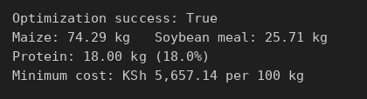
Figure 70: Program output: new/Task_19_chicken_feed.py
Interpretation: The cheapest mix is 74.3 kg maize and 25.7 kg soybean meal, exactly 18 % protein, costing KSh 5,657 per 100 kg. Adding more soybean would raise cost without being needed.

Task 20: Random Numbers and Monte Carlo Methods
Program file: code/Task_20_monte_carlo.py

B. Inputs and mathematical operation
- Inputs: capacity 1000; demand normal with mean 850 and standard deviation 120; 100,000 simulations.
- Operation: simulate demand, count cases above capacity, probability = overloaded / total.

Output of the original program
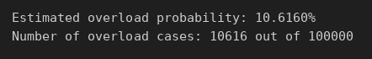
Figure 71: Program output: code/Task_20_monte_carlo.py
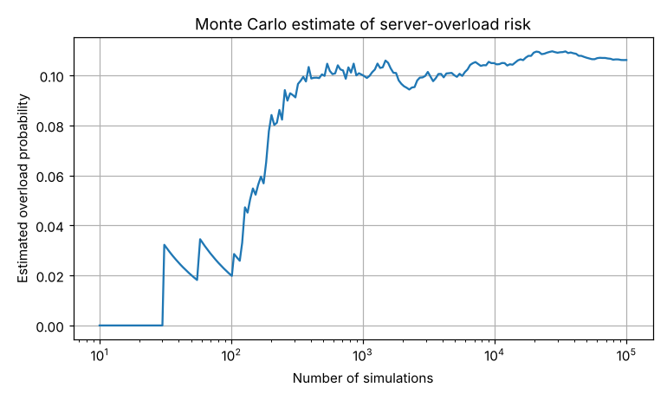
Figure 72: Graph produced by code/Task_20_monte_carlo.py

C. Parameter change and its effect
Change: Server capacity increased from 1000 to 1100.
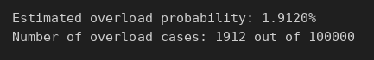
Figure 73: Program output after the change: changed/Task_20_monte_carlo.py
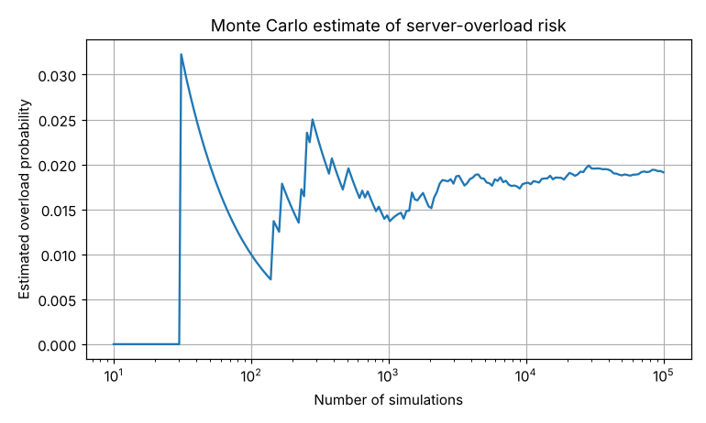
Figure 74: Graph after the change
Effect: The overload probability falls from 10.62 % to 1.91 %. Extra capacity of 100 units cuts the risk by more than five times.

D. Interpretation of the output
About 10.6 % of scenarios overload the server (the theoretical value is 10.56 %). The graph shows the estimate jumps around at first and settles near 0.106 after about 10,000 simulations.

E. Modified real-world case
Problem: What is the risk that a three-stage IT project misses its 30-day deadline?
Assumptions:
- Design 5–12 days (most likely 7).
- Build 10–22 days (most likely 14).
- Test 3–9 days (most likely 5).
- Triangular distributions; 100,000 simulations.
Input data: Three uncertain stage durations.
Code: new/Task_20_project_risk.py
import numpy as np
import matplotlib.pyplot as plt
# New case: risk that a 3-stage IT project misses a 30-day deadline.
# Each stage duration is uncertain (triangular: min, most likely, max days).
rng = np.random.default_rng(1)
N = 100_000
design = rng.triangular(5, 7, 12, N)
build = rng.triangular(10, 14, 22, N)
test = rng.triangular(3, 5, 9, N)
total = design + build + test
DEADLINE = 30
p_late = (total > DEADLINE).mean()
print(f"Mean project duration: {total.mean():.1f} days")
print(f"Probability of missing {DEADLINE}-day deadline: {p_late:.2%}")
print(f"Duration with 90% confidence: {np.percentile(total, 90):.1f} days")
plt.hist(total, bins=60)
plt.axvline(DEADLINE, linestyle="--", label="Deadline")
plt.xlabel("Total project duration (days)"); plt.ylabel("Number of simulations")
plt.title("Monte Carlo project-duration risk"); plt.legend(); plt.grid(True); plt.show()

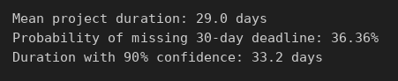
Figure 75: Program output: new/Task_20_project_risk.py
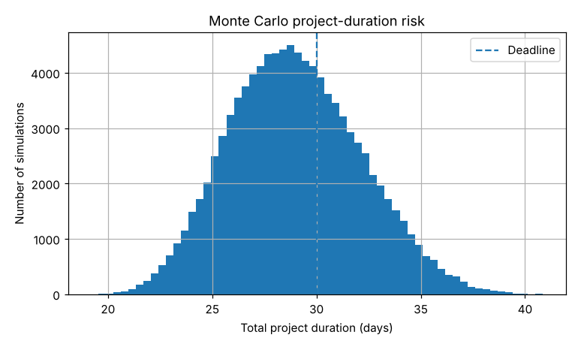
Figure 76: Graph produced by new/Task_20_project_risk.py
Interpretation: The average project takes 29 days, but there is a 36 % chance of missing the 30-day deadline. To be 90 % sure of finishing, plan for 33 days.

